<Partner Logo>

Cisco Webex Calling:

Cloud Calling Managed with Ease

Partner/Reseller Version



**Example Graphic Only**

**Please replace with an appropriate cover page image. You can also obtain images from** [**Cisco Partner Marketing**](http://bx.cisco.com/)**.**

**Suggested image size: 5.2”h x 7.33”w  
Layout: “Behind text” Wrapping**

Proposal for <<client>>

**April 2019**

This proposal is being provided by a Cisco authorized reseller utilizing a Cisco solution. Certain technical and other information in this response may have been provided by Cisco; however, nothing herein shall be construed as a quotation or offer to contract directly with Cisco. The Cisco logos, trademarks and other information provided by Cisco appear in this response with Cisco’s permission and are proprietary and confidential information of Cisco Systems, Inc. All other information, including any pricing information, is provided by the Cisco authorized reseller and not by Cisco, and any relationship resulting from this response will be directly with such reseller and not Cisco.

Template Instructions

**Template instructions are provided in text boxes as demonstrated below.**

**Note to USER: this is BOILERPLATE CONTENT. You will need to customize to fit the customer’s objectives and challenges. This proposal is provided as is and may not be appropriate for all situations.**

**reseller shall be responsible for the contents of this proposal.**

1. **Perform a manual Find and Replace on information found in << >> including the following fields in order to populate your custom information:**

<<client>>

<<PartnerName>>

<<UserName>>

<<UserPhone>>

<<UserEmail>>

<<UserFirstName>>

1. **Remove all yellow highlighted text within the document:**
   1. **Press Ctrl + A to select all text in the document.**
   2. **On the Home tab, in the Font group, click the arrow next to Text Highlight Color.**
   3. **Select No Color to remove yellow highlight from all text.**
2. **Insert Partner Logo and Customer Logo in the Header.**
3. **Delete all text boxes (as appropriate) before submitting to a customer.**
4. **Select the Table of Contents, press F9 to update or right-click and select Update Field. Then select one of the following options:**
   1. **Update page numbers only**
   2. **Update entire table**
5. **Note these best practices:**
   1. **When pasting in text, it is best to select “Keep Text Only” to preserve the formatting of this document.**
   2. **To add cells to a table, click on the table, and under the Table Tools > Layout box (for Mac users, select the Tables > Table Layout tab), select one of the insert row or column options.**
   3. **Utilize the document’s Style formats. They have been preformatted for ease of use.**
6. **Convert document to PDF before submitting to prevent unwanted changes.**
7. **Delete the Template Instructions page before submitting to a customer.**

Table of Contents

Simplify Business Communication for Your Organization 1

Proposed Cisco Webex Calling in the Cloud 1

Proposed Webex Calling Highlights 2

Proposed Cisco Webex Calling Benefits 2

Proposed Cisco Webex Calling Overview 4

Transform Your Calling Experience with a Complete Suite of Collaboration Applications 5

Webex Teams 5

Webex Meetings 6

Proposed Cisco Webex Calling Components 6

dCloud Demonstration 7

Services Overview 7

Services Help Deliver Greater Impact 7

Business Critical Services 7

Subscription-based Deployment Model 8

Cisco Collaboration Flex Plan 8

Financing Options 8

Cisco Capital 8

Pricing 10

Appendices 10



**Example Graphic Only**

**You can also obtain images from [Cisco Partner Marketing](http://bx.cisco.com/)**

**Suggested image size: 6.25”w x 1.7”h   
Layout: “In line with Text” Wrapping**

Simplify Business Communication for Your Organization

Your business is growing and everything is looking rosy. You’re attracting new customers and hiring new staff to meet their needs. Maybe you just moved to a bigger office. Or opened a new branch. Perhaps you’ve just acquired another company.

You’re starting to think about the tools people need to communicate and collaborate, and then you remember – that old phone system you’ve had for years has reached capacity. The company that provided it is no longer in business. Your heart sinks as you think about the hassle and cost of managing and maintaining multiple systems or going through a complex migration. Does this sound familiar?

You need a voice calling solution that is simple and easy to use, yet easy to maintain and scalable across distributed locations. It needs to embrace true mobility and allow for a seamless transition between work styles. <<PartnerName>> is pleased to propose the Cisco® Webex Calling solution.

Proposed Cisco Webex Calling in the Cloud

The proposed [Cisco Webex Calling](https://www.cisco.com/c/en/us/solutions/collaboration/webex-calling/index.html) solution is a cloud-based phone system and is part of the Cisco Webex suite of collaboration services, available through <<PartnerName>>. It is optimized for midsize businesses and provides the essential business calling capabilities you are likely to need. With the Cisco Webex Cloud, there’s no need to worry about the expense and complexity of managing phone system infrastructure on your premises anymore.

As part of this suite of products, the proposed Webex® Calling seamlessly integrates with [Cisco Webex Teams™](https://www.cisco.com/c/en/us/solutions/collaboration/webex-teams.html) and [Cisco Webex Meetings](https://www.cisco.com/c/en/us/products/conferencing/webex-meetings/index.html), so you can take collaboration inside and outside your organization to a new level. Your staff, customers, and business partners can make high-definition audio and video calls from the office, from home, or on the go. You can share screens, files, and messages, and can also whiteboard, to turn any call into a productive meeting. You can also add Cisco Webex Board, Room, or desk devices to help you get the most out of Webex Teams™ and Meetings and improve teamwork.

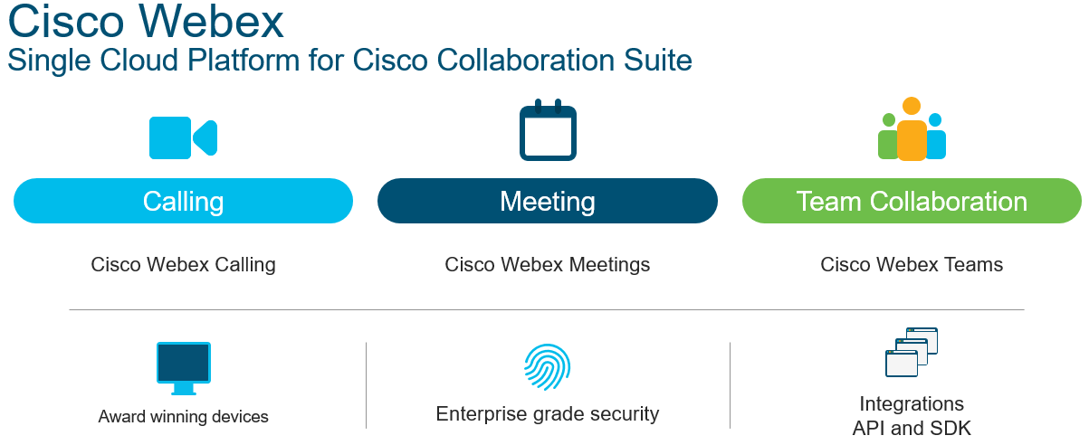

Proposed Webex Calling Highlights

The proposed Webex Calling is hosted in the Webex Cloud instead of on-premises so all you need to do is choose the options that best fit for your business:

* Choose from a wide range of Cisco IP phones, available through <<PartnerName>>, that meet the individual needs of your employees, including shared devices for lobby and reception areas and conference rooms.
* Receive essential features such as shared lines, hunt groups, hold, resume, pick up, forward, do not disturb, and transfer to help ensure that you never miss a call. Add a virtual receptionist to greet inbound callers.
* Reuse your existing telephone numbers and Public Switched Telephone Network (PSTN) by connecting through a Cisco-provided local gateway. Or ask <<PartnerName>> for guidance on choosing an alternative qualified service provider.
* Provide personalized voice mailboxes for every user. The Webex self-care portal means your employees can handle basic settings themselves.
* Use the proposed Webex Calling app or the included Webex Teams app on your computer, smartphone, or tablet to make and receive calls. Turn any call into a meeting, with instant desktop sharing of screens, files, and messages.

Proposed Cisco Webex Calling Benefits

The following describes how the proposed solutions can help you achieve your business objectives. All Cisco products mentioned are available through <<PartnerName>>.

|  |  |
| --- | --- |
| Desired Business Outcome | How We Can Make It Happen |
| **Phones for every user and office location** | The proposed Webex Calling supports a wide range of Cisco IP Phone 6800, 7800 and 8800 Series for any job role and office location—in the main office, in a branch, in public areas, in a conference room, or in your home office. All connected together by the proposed solution’s service. |
| **Comprehensive Private Branch Exchange (PBX) capabilities for business calling** | Welcome callers to your organization with a virtual receptionist, hunt and pickup groups, shared lines, and/or personalized voice mailboxes. Make calls with extension numbers, direct-inward-dial numbers, URIs (email-style addresses), or directory-based dialing. Enjoy mid-call features, including hold with music, resume, forward, and transfer. |
| **Enhanced communication and collaboration for mobile devices** | The proposed Webex Calling enables you to make and receive calls on your desktop and mobile devices wherever you are by using your choice of the included Webex Calling app or the Webex Teams app. With the Webex Teams app you can further enhance communication with a rich set of messaging, screen and file sharing, and meetings capabilities. |
| **Security and encryption** | Secure your communications and protect your business from threats. The proposed Webex Calling encrypts phone registration, activation, call signaling, and audio and video streams, as well as voicemail. Even the management is secure, because all administrative and end-user interfaces are encrypted. |
| **Simple cloud management** | The proposed Webex Calling is simple and intuitive to provision, manage, and use. Cisco takes care of the Webex Cloud so you can focus on running your business. The Webex Control Hub provides a simple interface for IT to make changes, and a self-care portal means users can handle basic settings and preferences for themselves. |

Proposed Cisco Webex Calling Overview

With the proposed solution, you can choose from a wide range of Cisco IP phones to make and receive calls. Enjoy the calling features you are used to from a traditional phone system to help run your organization smoothly and never miss a call. If you are a mobile worker, or you are out of the office, make and receive calls on your smartphone, computer, or tablet, using the included Cisco Webex Teams app.

Webex Calling Supports a Wide Range of Cisco IP Phones

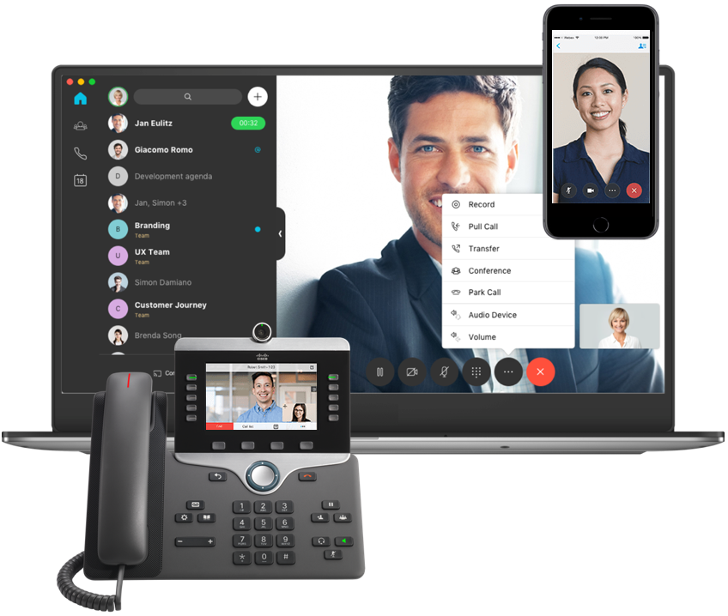

The proposed Webex Calling has features that are easy to use, empower callers, and create engaging experiences with less technology friction, to make collaboration feel more human:

|  |  |
| --- | --- |
| * HD audio and video calling | * Single number reach |
| * Directory-based dialing | * Resume |
| * Shared lines | * Call paging |
| * Conference calling | * Favorite personal contacts |
| * Speed dials | * Do not disturb |
| * Caller ID | * Call forward and transfer |
| * Virtual receptionist | * Personalized voice mailboxes |

Transform Your Calling Experience with a Complete Suite of Collaboration Applications

Redefine business calling in your organization with the complete Webex suite of applications offered by <<PartnerName>>. The proposed [Webex Calling](https://www.cisco.com/c/en/us/solutions/collaboration/webex-calling/index.html) seamlessly integrates with Webex Teams and Webex Meetings, to help you take collaboration inside and outside your organization to a new level. Your staff, customers, and business partners can make high-definition audio and video calls from the office, from home, or on the go. Share screens, files, messages, you can even whiteboard, to turn any call into a productive meeting. And when you add Cisco Webex Board, Room, or desk devices you get even more out of Webex Teams and Meetings and improve your teamwork.

Rich Modular Services Designed for How You Work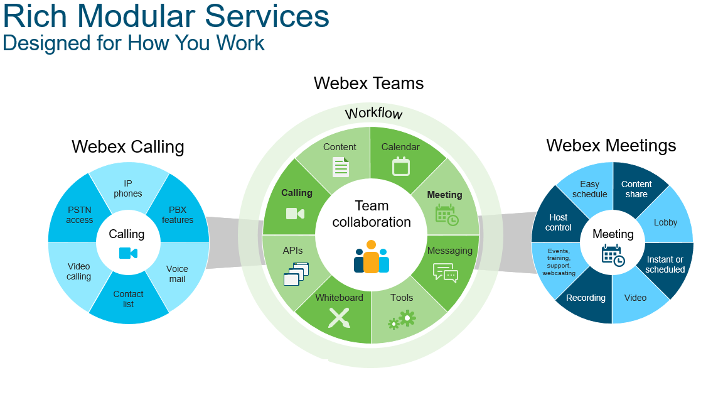

Webex Teams

Webex Teams allows for continuous teamwork. Bring people together from across organizations in a space to share messages and files securely. Escalate to, or schedule, a follow-up meeting to dive deeper, share ideas, and co-create with interactive whiteboard and annotation, and make decisions as a team. After the meeting, keep the conversation going in the same team space, iterating until you’ve achieved your objective.

With the proposed Webex Calling and Webex Teams together:

* Make, receive, or decline calls on your desk phone or with the Webex Teams app on your smartphone, PC, laptop, or tablet.
* Pair with Cisco IP Phones and Webex devices using Cisco Intelligent Proximity to access common contacts and call history on the app.[1]
* Turn any call into a productive meeting with a space for instant screen sharing, file sharing, messaging, and whiteboarding.[2]

Webex Meetings

Webex Meetings is an optional add-on app offered by <<PartnerName>> that helps you forget about technology, so you can focus on having productive meetings. Joining meetings is a breeze for everyone, no matter how they connect, even your guests. Audio and video are crystal clear and screen sharing super simple. Meet from anywhere using an app on your computer, smartphone, or tablet. Or join with a group of colleagues using a Webex Room Series device. Need a recording? That’s simple too. Just click the record button.

<Note to user: There are detailed [**Webex Meetings**](https://dcloud2-rtp.cisco.com/content/proposal/1031/download) and [**Webex Teams**](https://dcloud2-rtp.cisco.com/content/proposal/2761/download) proposals available on [**SalesConnect**](https://salesconnect.cisco.com/#/program/PAGE-3047) and [**dCloud**](https://dcloud.cisco.com/) for you to present to your potential customers.>

Proposed Cisco Webex Calling Components

<<PartnerName>> offers these components with the following features and benefits:

|  |  |
| --- | --- |
| Component | Description |
| [Cisco IP Phone 6800 Series](https://www.cisco.com/c/en/us/products/collaboration-endpoints/ip-phone-6800-series/index.html) | The Cisco IP Phone 6800 Series multiplatform phones are designed for affordability. The Cisco IP Phone 6841 and 6851 deliver reliable, business-grade audio, with Gigabit Ethernet integration and low power usage. Ideal for customers with moderate to active VoIP needs. |
| [Cisco IP Phone 7800 Series](http://www.cisco.com/c/en/us/products/collaboration-endpoints/unified-ip-phone-7800-series/index.html) | The Cisco IP Phone 7800 Series combines an attractive ergonomic design with "always-on" reliability and secure encrypted communications. This series delivers advanced IP Telephony features and crystal-clear wideband audio performance to deliver an easy-to-use, full-featured voice communications experience. |
| [Cisco IP Phone 8800 Series](http://www.cisco.com/c/en/us/products/collaboration-endpoints/unified-ip-phone-8800-series/index.html) | The Cisco IP Phone 8800 Series delivers highly secure, comprehensive, and mission-critical unified communications features. All this is combined with full-duplex, wideband audio performance. |
| [Cisco Headset 500 Series](https://www.cisco.com/c/en/us/products/collaboration-endpoints/headset-500-series/index.html)  Cisco 561 headset product photo | The Cisco Headset 500 Series delivers vibrant sound for open workspaces. Users can stay focused in noisy environments with rich sound, exceptional comfort, and proven reliability.  The 500 Series offers a lightweight form factor that is comfortable to wear, even for an entire workday. It’s designed for workers who spend a lot of time wearing headsets for voice communications and listening to music. |
| [Cisco ATA 190 Series Analog Telephone Adapter](https://www.cisco.com/c/en/us/products/collateral/conferencing/webex-meeting-center/datasheet-c78-740969.html) | The ATA 190-SC-K9 is a handset-to-Ethernet adapter that runs one traditional telephone device into the Cisco Webex Calling service. With one port, it supports analog voice and fax devices as well as analog paging systems. |
| [Cisco Local Gateway](http://www.cisco.com/c/en/us/products/unified-communications/expressway-series/index.html) | The Cisco local gateway is an enterprise-class gateway used to connect Webex Calling hosted in the Cisco cloud to a customer’s PSTN connection on-premises. This allows for breakout of PSTN calls made from endpoints connected to the Webex Calling solution. |

dCloud Demonstration

Experience the proposed solution’s components with cloud-based demonstrations. See for yourself on [Cisco dCloud](http://dcloud.cisco.com/) how they can benefit you. [Get started](https://dcloud-cms.cisco.com/help) with dCloud today or contact <<PartnerName>> at <<UserEmail>> or <<UserPhone>> for dCloud demonstration details.

Services Overview

Services Help Deliver Greater Impact

<<PartnerName>> provides access to [Cisco Services](https://www.cisco.com/c/en/us/services/overview.html), which are designed to deliver more simplicity, agility, and teamwork with a comprehensive portfolio focused on delivering value, enhancing processes, and leveraging data. Whether it’s setting a strategy, migrating to a new technology, or analyzing data to understand and optimize your solution, these services can help your technology reach its full potential.

You need next-generation infrastructure and a way to deliver scalable platforms for great digital experiences. Cisco’s approach to services transcends traditional advisory services, technical support, or implementation models to provide proactive, preemptive services for hardware, software, multivendor, and premium network-level support. Cisco experts are available worldwide, around-the-clock, to help make sure your IT works—simply, consistently, and securely.

And through continuous innovation, Cisco offerings evolve to address emerging trends and technologies, such as cloud and automation, and help you extract maximum value from your resources. Cisco uses intellectual capital gained from millions of global customer interactions, applying the best practices it’s learned to align with your needs—helping you speed innovation, minimize risk, and maintain security.

**<Note to user: Cisco Services partner proposals are available on** [**SalesConnect**](https://salesconnect.cisco.com/#/program/PAGE-12599) **and** [**dCloud**](https://dcloud.cisco.com/) **for you to present to your potential customers. These partner proposals detail a wide range of services delivered by Cisco experts to help your customers get the most from their Cisco solutions.>**

Business Critical Services

<<PartnerName>> are pleased to offer [Cisco Business Critical Services](https://www.cisco.com/c/en/us/services/optimization.html?dtid=osscdc000283), Cisco’s next generation of optimization services. They combine the company’s unrivaled engineering expertise with integrated analytics and automation to enable you to predict opportunities, preempt risks, and navigate pivotal technology transitions. Organized across three themes—Foundation, Acceleration, and Transformation—these services can assist in meeting your needs at any stage of your digital transformation journey.

Cisco experts help you ensure a secure, efficient, and agile infrastructure with less risk, while enabling business growth and increased productivity. Services cover Analytics, Automation, Design Engineering, Compliance and Remediation, Security, and more, with Cisco expert recommendations on how to align with best practices as you optimize your technologies. Cisco Business Critical Services can accelerate your IT transformation and help you realize the high-impact business outcomes you seek.

With this support from the start, you can be better poised for success.

Subscription-based Deployment Model

**<There is a detailed** [**Cisco Collaboration Flex Plan – Proposal Template for Partner Sales**](https://dcloud2-rtp.cisco.com/content/proposal/5420/download) **for you to share with your potential customer. Please visit the Proposal Library at:** [**https://proposals.cisco.com/**](https://proposals.cisco.com/)**>**

Cisco Collaboration Flex Plan

<<PartnerName>> offers [Cisco Collaboration Flex Plan](https://www.cisco.com/c/en/us/products/unified-communications/collaboration-flex-plan/index.html) which includes cloud and on-premises collaboration deployment models in one subscription-based offer. This is a simple and economical way for you to make the transition to the cloud.

One agreement covers software, licensing, and technical support for the Cisco Webex suite, combined with on-premises Cisco UCM deployments.

With company-wide coverage for team collaboration for any organization with 250 or more users, Cisco Collaboration Flex Plan helps you ensure users in your organization have access to the services they need, without being concerned with how they’re delivered

Financing Options

Cisco Capital

<<PartnerName>> offers [Cisco Capital®](http://www.ciscocapital.com/) financial services which is a wholly owned subsidiary of Cisco. The mission is to provide maximum value to customers through industry-leading vendor financing that enables desired business outcomes. These tailored financial solutions for Cisco hardware, software, and services can be customized based upon the specific needs of each customer – including competitive rates, flexible terms, and migration options. Cisco Capital financing can maximize the value of technology by reducing TCO, managing cash flow, conserving capital, lifecycle management, and protection against technology obsolescence.

Exceed your company’s financial and technology goals through financing:

* Customized terms up to five years with leasing or financing options
* Flexible migration options to manage equipment lifecycles, avoid obsolescence, and responsibly dispose of equipment
* Payment deferrals to help align to budget cycles and ROI goals
* Aggressive residuals on Cisco hardware that can lower your overall solution cost
* Below-market rates for Cisco subscription-based services

For more information, visit: <http://www.ciscocapital.com>such as driving productivity, maintaining profitability, and improving competitiveness through innovation.

Pricing

**<Note to user: Insert bill of materials (BOM) / pricing details, or remove this section as appropriate.**

**If applicable, be sure to provide a BOM summary before inserting a BOM / pricing information.>**

Appendices

**<Note to user: Use this section to respond to customer questions, provide any additional information, or remove this section as appropriate.>**

1. Cisco IP Phone 8845, 8851, 8861, and 8865 phones only, available through <<PartnerName>>
2. Screen sharing for desktop users only.